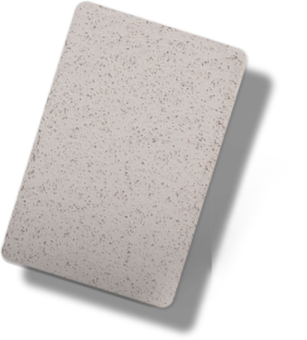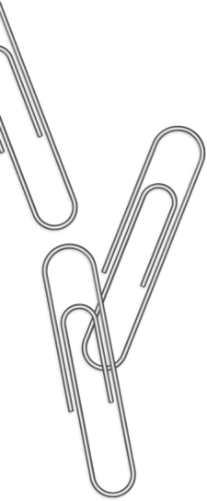

**RASPORED SATI**

|  |  |
| --- | --- |
| 1. |  |
| 2. |  |
| 3. |  |
| 4. |  |
| 5. |  |
| 6. |  |
| 7. |  |
| 8. |  |

Vrijeme nastave

|  |  |
| --- | --- |
| 1. |  |
| 2. |  |
| 3. |  |
| 4. |  |
| 5. |  |
| 6. |  |
| 7. |  |
| 8. |  |

SUBOTA

|  |  |
| --- | --- |
| 1. |  |
| 2. |  |
| 3. |  |
| 4. |  |
| 5. |  |
| 6. |  |
| 7. |  |
| 8. |  |

PETAK

|  |  |
| --- | --- |
| 1. |  |
| 2. |  |
| 3. |  |
| 4. |  |
| 5. |  |
| 6. |  |
| 7. |  |
| 8. |  |

ČETVRTAK

|  |  |
| --- | --- |
| 1. |  |
| 2. |  |
| 3. |  |
| 4. |  |
| 5. |  |
| 6. |  |
| 7. |  |
| 8. |  |

UTORAK

|  |  |
| --- | --- |
| 1. |  |
| 2. |  |
| 3. |  |
| 4. |  |
| 5. |  |
| 6. |  |
| 7. |  |
| 8. |  |

SRIJEDA

|  |  |
| --- | --- |
| 1. |  |
| 2. |  |
| 3. |  |
| 4. |  |
| 5. |  |
| 6. |  |
| 7. |  |
| 8. |  |

PONEDJELJAK

|  |  |
| --- | --- |
| 1. |  |
| 2. |  |
| 3. |  |
| 4. |  |
| 5. |  |
| 6. |  |
| 7. |  |
| 8. |  |